GUIDELINES FOR PREPARATION OF DIGESTS FOR THE ПЕС 2025
17th INT. CONFERENCE ON APPLIED ELECTROMAGNETICS
First AUTHOR, Second AUTHOR and Third AUTHOR

Abstract: This sample contains guidelines for preparation of digests for the ПЕС 2025 Conference which will be held in Niš, Serbia, August 27-29, 2025. The digest should contain the title, authors’ names and their affiliations, some keywords possibly selected from the topics of the conference, as well as brief, clearly given information about the paper’s purpose, its topic, achievement, some results, and used methodology.
Keywords: Up to five, in alphabetical order.
INTRODUCTION
These guidelines are saved as a Microsoft Word 97-2003 document. Please, use this file as a template for your paper.
The length of the digest should be one page of A4 format in total, two-column text with the space between columns of 0.5 cm. The page setup is: top margin 2.5 cm, bottom margin 2 cm, left margin 2 cm, and right margin 1.5 cm. Do not number the pages.
If you have any question about this template, please contact the editor via pes@elfak.rs.
PAPER ATTRIBUTES
Font and styles
Please, use only Times New Roman font. Several styles for different sections of the paper are given in these guidelines. All the styles employ single-spaced paragraphs, 3 pt before, with first line 0.5cm from left side. The title, authors’ names, table and figure captions are centred. The affiliation, headings and subheadings are left aligned. The font size, styles and spacing are shown in the Table I.
$\text{rot}H=σE+j{\text{ωε}}_{r}ε_{0}E\text{.}$ (1)
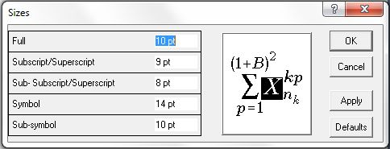
Fig.1 - Caption of the figure 1.
Figures, tables and equations
Tables and figures should be centred in the columns or over the whole page width. Table captions should be over the table, as in Table I (only with horizontal borders). Figure contents and figure caption should be in one column, put in two-rows table without exterior border. Equations should be centred and numbered flush right, as in Eqn. (1).
Table I
Font sizes and appearance for the styles.
Style | Font  size | Appearance | Space before | Space  after
TITLE | 14 | Bold | 40 pt | 0 pt
Authors | 12 | Normal | 12 pt | 12 pt
Affiliation | 8 | Normal | 0 pt | 0 pt
Abstract | 9 | Bold/  Normal | 0 pt | 0 pt
Keywords | 9 | Bold/  Normal | 6 pt | 0 pt
HEADING | 10 | Bold | 12 pt | 0 pt
Text | 10 | Normal | 3 pt | 0 pt
Subheadings | 10 | Bold | 6 pt | 0 pt
Figure  Caption | 9 | Bold/  Italic | 3 pt | 3 pt
Figure  contents |  |  | 3 pt | 3 pt
Table | 9 | Bold | 6 pt | 0 pt
Table  Caption | 9 | Italic | 0 pt | 3 pt
References | 9 | Normal | 3 pt | 0 pt
Equations |  |  | 3 pt | 3 pt
CONCLUSION
Please pay attention to the language, employ the English (UK) spell checker and automatic hyphenation.
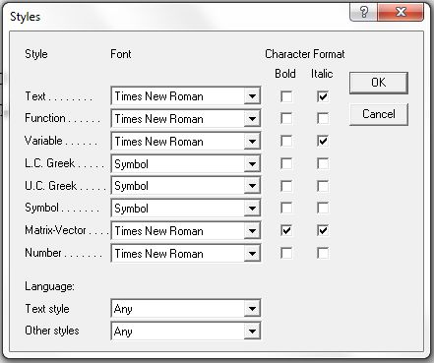
Fig.2 - Caption of the figure 2.
When submitting the digest using the online paper submission application do not forget to upload both .PDF and .DOC files.
Digest should be submitted online through the official website of ПЕС 2025: http://pes.elfak.rs/pes-authors-corner/paper-submission-form/.
All references should be numbered in square brackets both in the list of references and when citing them [1]. Use italic for book titles, as in [2]. If the book or paper is not in English, give the title translated into English and the language of original in brackets. References should be numbered using "Numbering", having 0cm for the first line and hanging of 0.6cm. On the last page of your paper equalise the length of the columns.
References
[1] F. Author, S. Author, T. Author: “Title of the paper with only first letter capitalized”, Journal name or Conference proceedings, Vol. 2, 2001, pp. 135-138.
[2] F. Author, S. Author: “Title of the book with only first letter capitalized”, Editor, 2001, New York.

University of Niš, Faculty of Electronic Engineering, Aleksandra Medvedeva 14, 18000 Niš, Serbia, e-mail: nebojsa.raicevic@elfak.ni.ac.rs
Ilmenau University of Technology, Faculty of Electrical Engineering and Information Technology, P.O.Box 100565, D-98684 Ilmenau, Germany, e-mail: hartmut.brauer@tu-ilmenau.de
Technical University of Sofia, Kliment Ohridski 8, Sofia 1000, Bulgaria, e-mail: yatchev@tu-sofia.bg

